**16.4. Spring MVC Form Validation** **String Input for Integer Field**

**Spring MVC Form Validation String Input for Integer Field**:

In our form we validate our “Free Passes” field for a range of number (min and max) and make validate it for null value. Now we make a validation for string input. In this field Integral value is required if user insert string value it will display a custom message.

Before validation if user insert string value in this field it will display the following message.

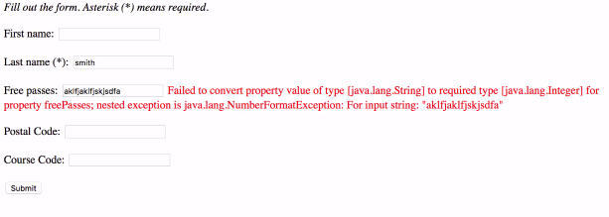

**Development process (String Input for Integer Field)**:

1. Create custom error message

src/resources/messages.properties

1. Load custom message resource in spring config file.

WebContent/WEB-INF/spring-mvc-demo-servlet.xml

**File: messages.properties**:

typeMismatch.customer.freePasses=Invalid Number

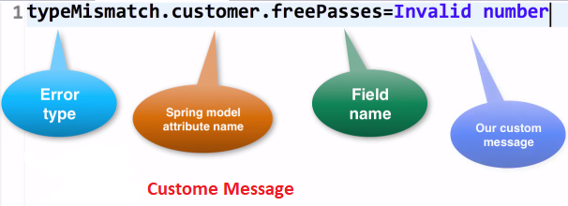

**File: spring-mvc-demo-servlet.xml**:

<?xml version=*"1.0"* encoding=*"UTF-8"*?>

<beans xmlns=*"http://www.springframework.org/schema/beans"*

xmlns:xsi=*"http://www.w3.org/2001/XMLSchema-instance"*

xmlns:context=*"http://www.springframework.org/schema/context"*

xmlns:mvc=*"http://www.springframework.org/schema/mvc"*

xsi:schemaLocation=*"*

*http://www.springframework.org/schema/beans*

*http://www.springframework.org/schema/beans/spring-beans.xsd*

*http://www.springframework.org/schema/context*

*http://www.springframework.org/schema/context/spring-context.xsd*

*http://www.springframework.org/schema/mvc*

*http://www.springframework.org/schema/mvc/spring-mvc.xsd"*>

<!-- Step 3: Add support for component scanning -->

<context:component-scan

base-package=*"com.ruhul.odduu"* />

<!-- Step 4: Add support for conversion, formatting and validation support -->

<mvc:annotation-driven />

<!-- Step 5: Define Spring MVC view resolver -->

<bean

class=*"org.springframework.web.servlet.view.InternalResourceViewResolver"*>

<property name=*"prefix"* value=*"/WEB-INF/view/"* />

<property name=*"suffix"* value=*".jsp"* />

</bean>

<!-- Load custom message resources -->

<!-- bean id and class name must be the same -->

<bean id=*"messageSource"*

class=*"org.springframework.context.support.ResourceBundleMessageSource"*>

<!-- Loads: resources/messages.properties -->

<property name=*"basenames"* value=*"resources/messages"* />

</bean>

</beans>

In the above “**spring-mvc-demo-servlet.xml**” file we add the following code

<!-- Load custom message resources -->

<!-- bean id and class name must be the same -->

<bean id=*"messageSource"*

class=*"org.springframework.context.support.ResourceBundleMessageSource"*>

<!-- Loads: resources/messages.properties -->

<property name=*"basenames"* value=*"resources/messages"* />

</bean>

16.4. SpringMVC-formValidation-stringInput-for-integerField